Chicago Style (CMS): Formatting Your Paper
Unlike the other citation styles used at universities (MLA and APA), the Chicago Style of citation requires that the student use either footnotes or endnotes. Certain academic fields like history or some social science disciplines will require Chicago Style, because the sources used for an argument in these disciplines are considered to be especially important. The typeface should be something readable like Times New Roman and the font size should be no less than 10pt.
CMS requires that writers document their sources in 2 separate places. The first place is in either the footnote or endnote. The other place is in the bibliography, which is placed on its own sheet of paper at the end of a research paper.
If you haven’t used footnotes before, composing them correctly can seem confusing. Use this handout, which focuses on the overall format of a paper with footnotes or endnotes, along with a second handout we’ve created called Chicago Style: Formatting Footnotes & Bibliography. This second handout looks more closely at the order within a particular footnote and a bibliography citation.

Your word processor can help!
When you’re writing your research paper and are ready to cite a source for a particular sentence, MS Word has a function that makes creating a footnote or endnote much easier. With your cursor placed on the spot where you want the footnote number to appear, click References on the toolbar, then look for the Footnote section. The program then allows you to choose to use either footnotes or endnotes (you’ll have to be consistent in your choice throughout the whole document!), and will insert the correct footnote number in the text. It will even move your cursor automatically to the footnote or endnote itself, ready for you to fill in the citation information (see our other handout, Chicago Style: Formatting footnotes and bibliography citations, for help on that process).

Footnotes or Endnotes?
Which is better, footnotes or endnotes? Endnotes appear all together at the end of the document, while footnotes will be at the bottom of every page on which you use a source. While it can be easier on you as the writer to use endnotes, footnotes give readers the ability to immediately contextualize your source instead of flipping to the endnotes. Writing the footnotes at the same time as the paper can also help you keep track of why each quotation and source you are using is important to your paper. Generally, you’ll get to choose between the two, unless your instructor gives you specific instructions.

Why use footnotes/endnotes?
Footnotes and endnotes allow you to give context for a source without having to move away from your main argument. For example, in disciplines such as philosophy, you may want to refer to a theory that is relevant to your argument but is not the main focus of your paper. You can briefly mention the theory in the body paragraph and explain it a footnote/endnote to help keep your argument clear. Or, in a history paper, you can mention a historical event in your body paragraph and explain the important details in the footnotes/endnotes.
Footnotes/endnotes give readers the option to read this material at their own convenience, without forcing them off-track from the point you’re making in the main text.
Here is a sample bibliography page:

BIBLIOGRAPHY

Cory, Donald Webster. The Homosexual in America: A Subjective Approach. New York: Castle Books, 1960 (originally 1951).

Foucault, Michel. The History of Sexuality: An Introduction, Vol. I. New York: Vintage Books, 1990 (originally 1976).

Irvine, Janice. “Toward a ‘Value-Free’ Science of Sex: The Kinsey Reports” in Sexualities in History (ed. Kim Phillips and Barney Reay). New York: Routledge, 2002.

Kardiner, Abram. Sex and Morality. Indianapolis: Bobbs-Merrill Co., 1954.

Kinsey, Alfred; Pomeroy, Wardell; Martin, Clyde. Sexual Behavior in the Human Male. Philadelphia: W.B. Saunders Co., 1949 (originally 1948).

----------. Sexual Behavior in the Human Female. Philadelphia: W.B. Saunders Co., 1953.

May, Elaine Tyler. Homeward Bound : American Families in the Cold War Era. New York: Basic Books, 1988.

“Must be Change our Sex Standards?” Reader’s Digest (June 1948): 1-6.

Pomeroy, Wardell. Dr. Kinsey and the Institute for Sex Research. New Haven: Yale Press, 1982.

Trilling, Lionel. “The Kinsey Report” in The Liberal Imagination. Garden City: Doubleday, 1950 (article originally published 1948).

United States Congress, Senate, Committee on Expenditures in the Executive Departments, Subcommittee on Investigations. Employment of Homosexuals and Other Sex Perverts in Government. (81st Congress, 2nd Session, Document No. 241, December 15, 1950).

Page 21

Here is a sample page of a paper, complete with footnotes:

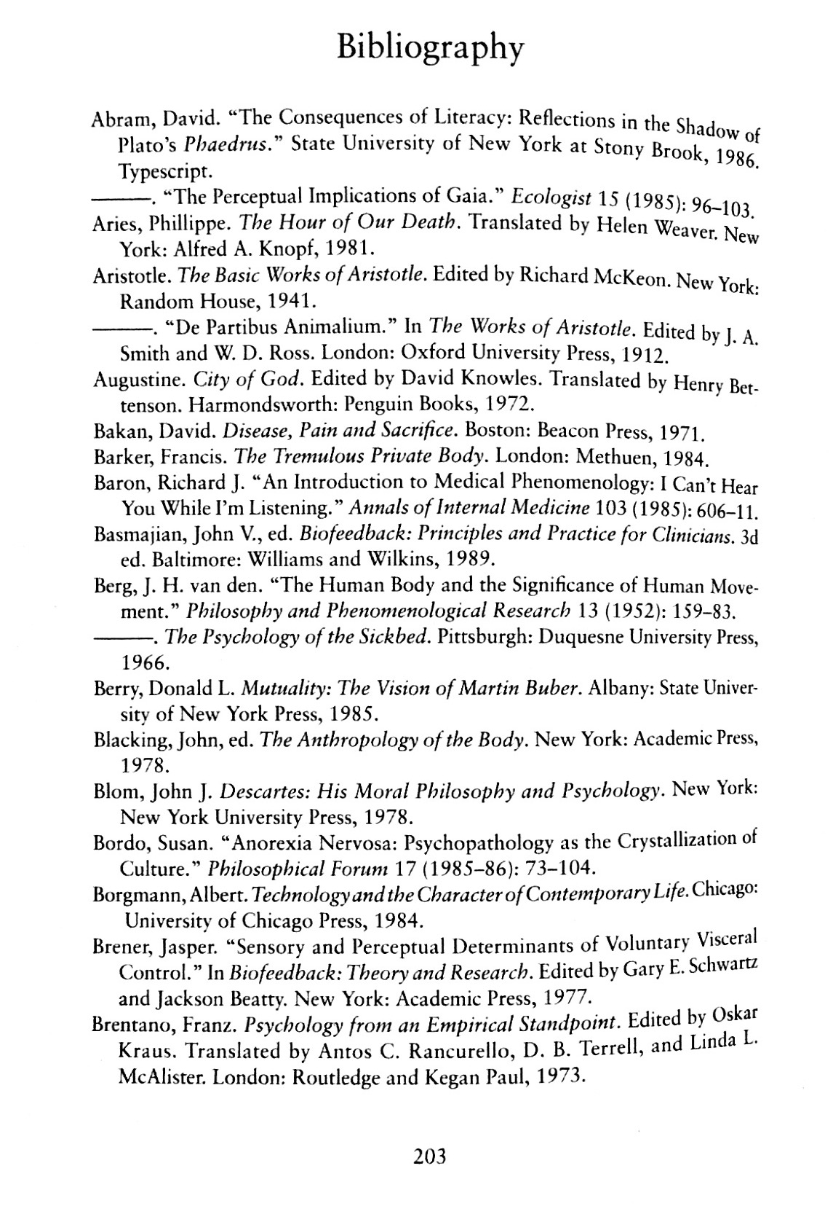
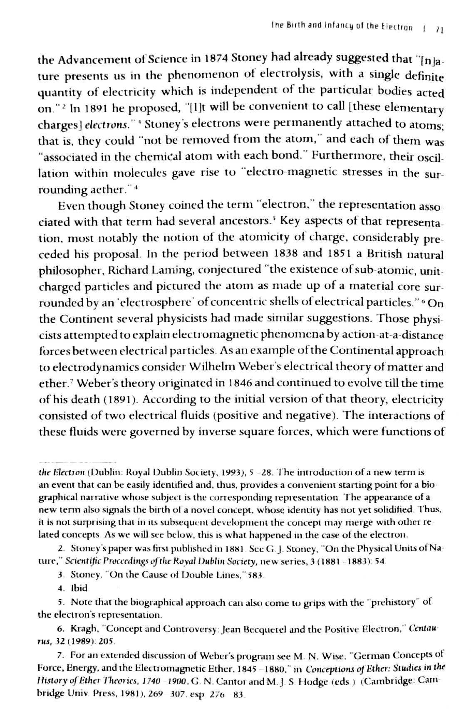
Here is a sample bibliography page:
These sample pages are taken directly from the Chicago Manual of Style, 16th edition (2010).

Sample page of a paper: Figure 14.1
Sample bibliography page: Figure 14.8

